*) created projectecomproject

*) apps ecomshop, ecomblog

*) made basic settings.

*) go to getbootstrap.com-> documentation -> starter template

*) templates->ecomshop in ecomshop apps

*) templates->ecomblog in ecomblog apps

*) templates->ecomblog -> index.html paste starter template from getbootstrap in

here

*) runserver, see change design

*) do the same for ecomshop

*) creating static folder in both apps

*) {% load static %}

in index.html of ecomblog

<a href="{% static 'ecomblog/firstblog.txt' %}">Click me</a>

this will display elements of that

*) with this I've displayed image

<img src="{% static 'images/article.png' %}" alt="">

*) creating many functions for about, contact, search, productview etc...

*) ===============================

ecomshop.apps.EcomshopConfig

Instead of putting app name in settings you can also put above name

both are same.

Go to ecomshop->apps-> you'll see class name EcomshopConfig

so you can mention like "ecomshop.apps.EcomshopConfig"

you won't get any error.

=====================================

*) creating models: models will map to database table

each attribute of model represents database field

Django documentation

*) class Product(models.Model):

product_id = models.AutoField

AutoField: django field reference-> model fiel reference search these things in

google

AutoField: intergerfield automatically incremenetes according to availabale ids

desc = description

*) python manage.py createsuperuser

12345678 password

*) register in admin

========================

*) homepage in ecomshop: bootstrap-> documentation-> componenets -> navbar

copy that html codes and paste it in below mentioned location.

remove ""<h1>Hello, world!, for shop</h1>"" this in index.html

paste contenets from bootstrap.

================================================

=================================================

Means HERE ITEMS WILL SCROLL FROM LEFT TORIGHT AND RIGHT TO LEFT YOU WILL KEEP TWO BUTTONS TO MOVE

OR SEE NEXT ITEMS IN ROW, LIKE IN AMAZON WEBSITE IN A SINGLE ROW LIST OF LAPTOPS WILL BE THERE AS

YOU PRESS ON ">" ITEMS WILL MOVE TO RIGHT MEANS NEXT LAPTOPS WILL COME SO THAT YOU CAN SEE OTHER LAPTOPS.

""crowsel in bootstrap""

After nav bar inserting div tag

<ul class="carousel-indicators">

<li data-target="#demo" data-slide-to="0" class="active"></li>

<li data-target="#demo" data-slide-to="1" ></li>

<li data-target="#demo" data-slide-to="2" ></li>

</ul>

<!-- Slideshow starts here -->

<div class="container carousel-inner no-padding">

<div class="col-xs-3 col-sm-3 col-md-3">

here copying card from bootstrap and pasting it here

</div>

</div>

================

<div class="col-xs-3 col-sm-3 col-md-3">

<div class="card" style="width: 18rem;">

<img src="..." class="card-img-top" alt="...">

<div class="card-body">

<h5 class="card-title">Card title</h5>

<p class="card-text">Some quick example text to build on the card title and make up the bulk of the card's content.</p>

<a href="#" class="btn btn-primary">Go somewhere</a>

</div>

</div>

</div>

===================copy and pasting this 3 times

After adding class webpage will look like this.

I have added this div tag

<div class="carousel-item active">

And corrected indenatation

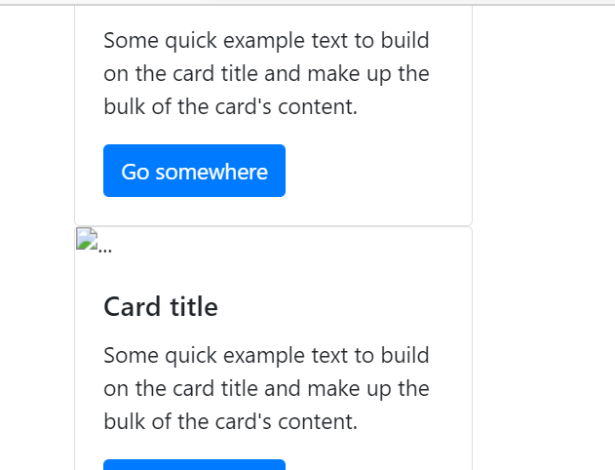

Copy and pasting this and making 3 slides:

<div class="carousel-item active">

        <div class="col-xs-3 col-sm-3 col-md-3">

          <div class="card" style="width: 18rem;">

            <img src="..." class="card-img-top" alt="...">

              <div class="card-body">

                <h5 class="card-title">Card title</h5>

                <p class="card-text">Some quick example text to build on the card title and make up the bulk of the card's content.</p>

                <a href="#" class="btn btn-primary">Go somewhere</a>

              </div>

            </div>

        </div>

        <div class="col-xs-3 col-sm-3 col-md-3">

          <div class="card" style="width: 18rem;">

            <img src="..." class="card-img-top" alt="...">

            <div class="card-body">

              <h5 class="card-title">Card title</h5>

              <p class="card-text">Some quick example text to build on the card title and make up the bulk of the card's content.</p>

              <a href="#" class="btn btn-primary">Go somewhere</a>

            </div>

          </div>

        </div>

        <div class="col-xs-3 col-sm-3 col-md-3">

          <div class="card" style="width: 18rem;">

            <img src="..." class="card-img-top" alt="...">

            <div class="card-body">

              <h5 class="card-title">Card title</h5>

              <p class="card-text">Some quick example text to build on the card title and make up the bulk of the card's content.</p>

              <a href="#" class="btn btn-primary">Go somewhere</a>

            </div>

          </div>

        </div>

      </div>

But remove active in div tag slides

Adding style css after title tag

   .col-md-3{

        display: inline-block;

        margin-left: -4px;

      }

      .col-md-3 img{

          width: 100%;

          height: auto;

      }

After this

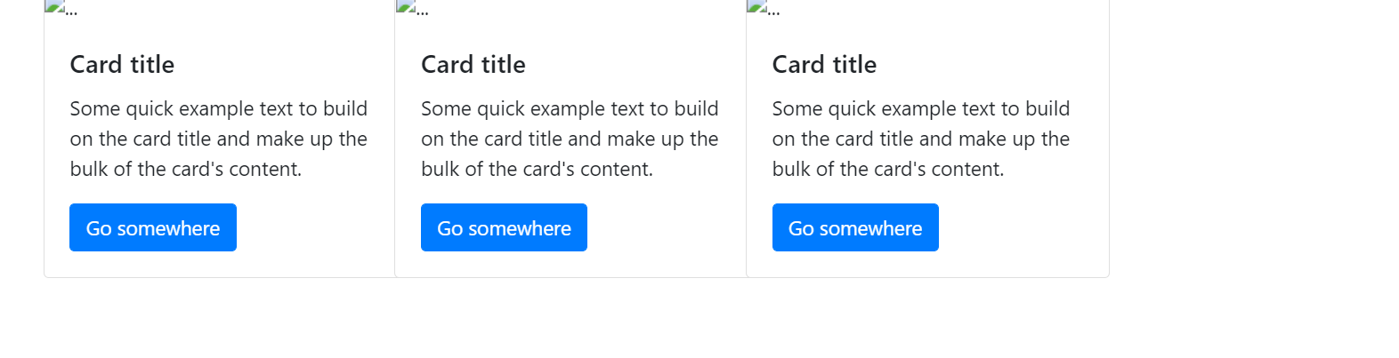

 <div id="demo" class="carousel slide" data-ride='carousel'>

Added this just above

<ul class="carousel-indicators">

Code to insert button for left or right

<a class="carousel-control-prev" href="#demo" data-slide='prev'>

  <span class="carousel-control-prev-icon"></span>

</a>

Made a little bit mistake by spelling mistake

body .carousel-control-pref-icon,

      body .carousel-control-next-icon{

        background-color:blue;

SO prev button was not displaying

Changing color of line

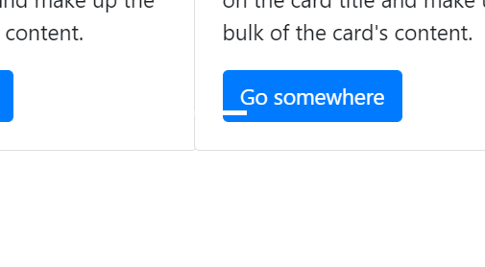

Do ctrl+f for searching … where you need to place image

<div class="card" style="width: 18rem;">

            <img src="..." class="card-img-top" alt="...">

              <div class="card-body">

After load static and mentioning image fiel with staic displaying like below

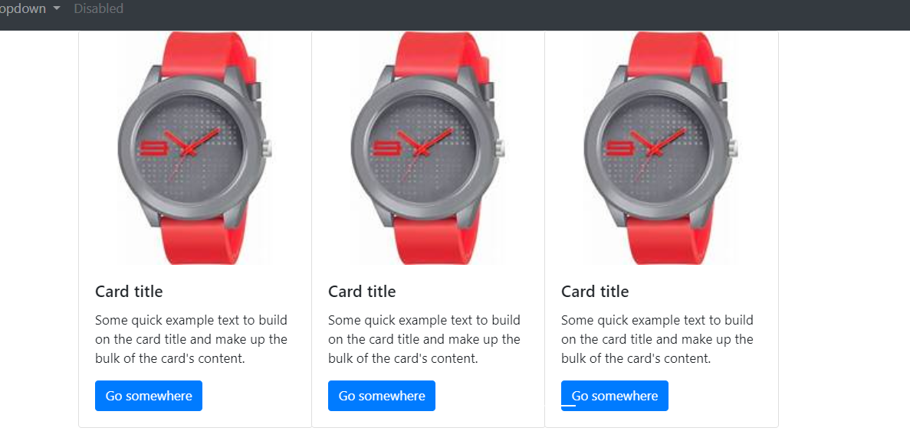

<div class="container"></div>

  <div id="demo" class="carousel slide my-3" data-ride='carousel'>

Putting container

my-3 with this we are giving margin box will slightly come down from url bar on web page.

Adding images::

Adding fields in models.py

 category  =models.CharField(max_length=50,default='')

    subcategory  =models.CharField(max_length=50)

    price = models.IntegerField()

    desc = models.CharField(max_length=300)

    pub_date = models.DateField()

    image = models.ImageField(upload_to='ecomshop/images')

We’re seeing products in admin page instaed we want to check item names.

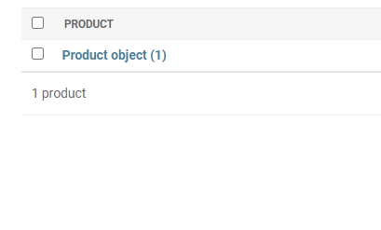

For that add function in models.py

def __str__(self):

        return self.product_name

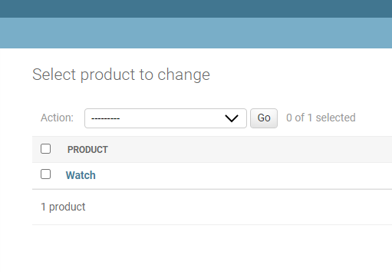

In admin page we can directly upload image but it is not a proper way.

We need to create media directory in that only we need to upload images

In settings.py

# Managing media

MEDIA_ROOT = os.path.join(BASE_DIR,'media')

MEDIA_URL = '/media/'

Importing settings in ecomproject -> urls.py

from django.conf import settings

from django.conf.urls.static import static

urlpatterns += static(settings.MEDIA_URL,document_root = settings.MEDIA_ROOT)

AFTer this when you upload images in Django-admin web page it will upload in media directory

And I have given directory models as ecomshop/images so directory of image will be

Media-> ecomshop/images/watch.png

Naming of product and using manage.py shell

from ecomshop.models import Product

from django.utils import timezone

>>> myprod = Product(product_name='Acer',category='computers',subcategory='electronics',price=20000,desc='core i5, 8th gen 256GB ssd',pub_date=timezone.now())

Querying:

Product.objects.get(product_name='Acer')

<Product: Acer>

Template inheritance

Like footer should display in all web page of home about contact we cannot same code again and again.

Create about.html and basic.html

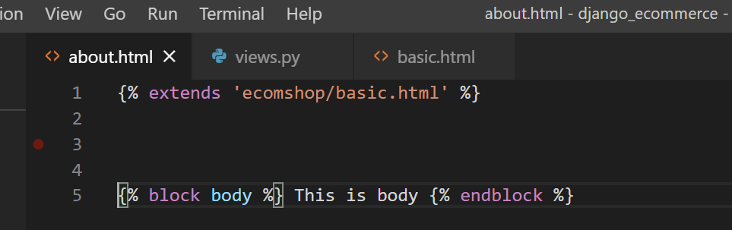

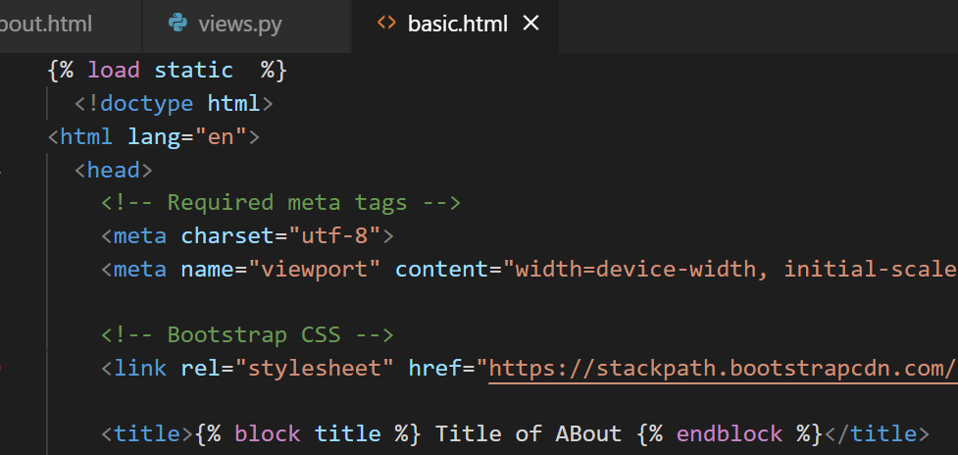

Adding block body in basic.html finally web page looks like

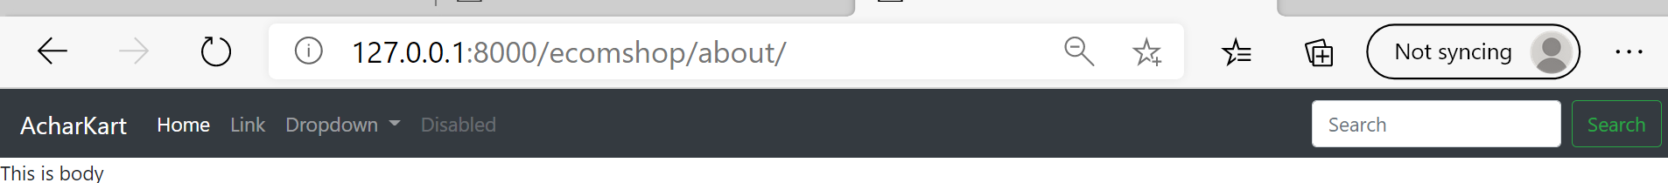

Now inherting basic.html in index.html

Will get this error when you use load static only in basic.html but not in index.html

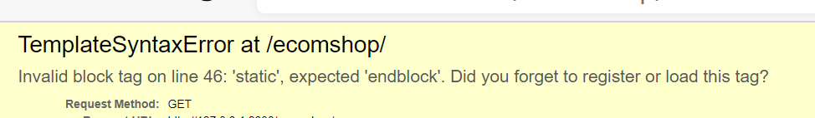

Now added load static in index.html error removed:

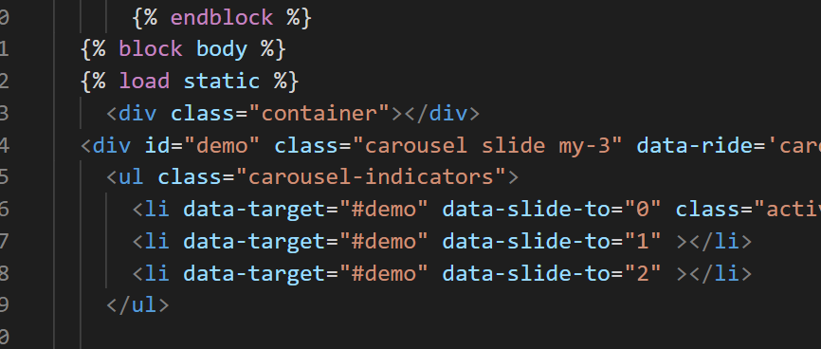

Other than that we are now extending everything from basic.html

In index.html I have kept only css part and carousel part.

Logic for slides:



If 4 items then 4//4+ ceil(4/4-4//4) = 1+ 0

If 7 items then 7//4 + ceil(0.75) = 1+ 1 = 2slides will be there. For 7 items.

Add 8 to 9 items in Django admin page, after I need to fetch them from database and I need to display them in web page.

Taking all products from database.

def index(request):

    products = products.objects.all()

    params = {}

    return render(request,'ecomshop/index.html',params)

below code will take

in products = products.objects.all()

Look carefully in the output section of vscode once when you add more products on admin web page

Do runserver that time

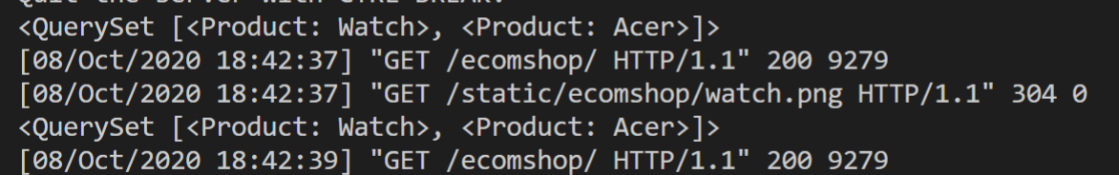

<QuerySet [<Product: Watch>, <Product: Acer>, <Product: Washing Machine>, <Product: Air condition>, <Product: Camera>]>

[08/Oct/2020 19:02:51] "GET /ecomshop/ HTTP/1.1" 200 9279

Now passing products as template to params

params = {'product':products}

n = len(products)

nslides = n//4+ m.ceil((n/4)-n//4)

params = {'no_of_slides':nslides,'range':range(nslides),'product':products}

next go to index.html

Now doing exact carousel

**Carousel widget:**

The Carousel widget provides the classic mobile-friendly carousel view where you can swipe between slides. You can add any content to the carousel and have it move horizontally or vertically. The carousel can display pages in a sequence or a loop.

‘itemranges’:range(1,nslides)

From 1st slide to no of items depending on no of items

  <div class="container"></div>

  <div id="demo" class="carousel slide my-3" data-ride='carousel'>

    <ul class="carousel-indicators">

      <li data-target="#demo" data-slide-to="0" class="active"></li>

      {% for i in itemranges %}

      <li data-target="#demo" data-slide-to="{{i}}" ></li>

      {% endfor %}

    </ul>

Removing dataslide=2

Itemranges cottanins numbers from 1 to no o fitem

Now gotos slideshow

Here <div class="container carousel-inner no-padding">

      <div class="carousel-item active">

Inside <div class="carousel-item active"> we have 3 items

We need to keep one slide. In one slide I have put 3 items.

After 4 div 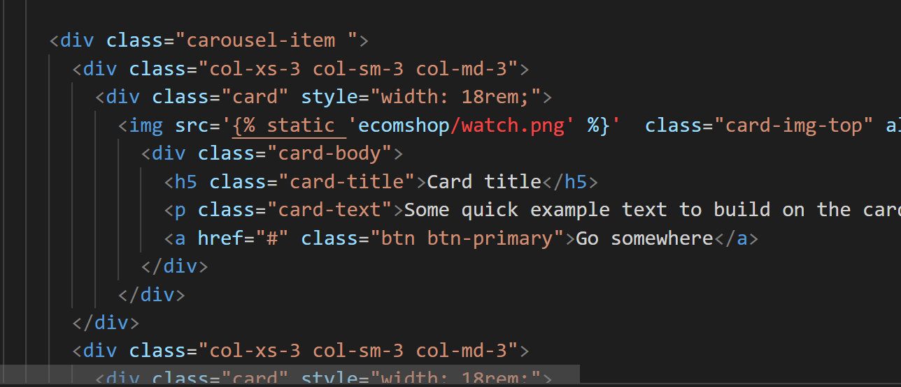

From here 2nd slide starts

Now 4 items will visible in web page in 1 slide.

Put another for loop in

From first to all product  
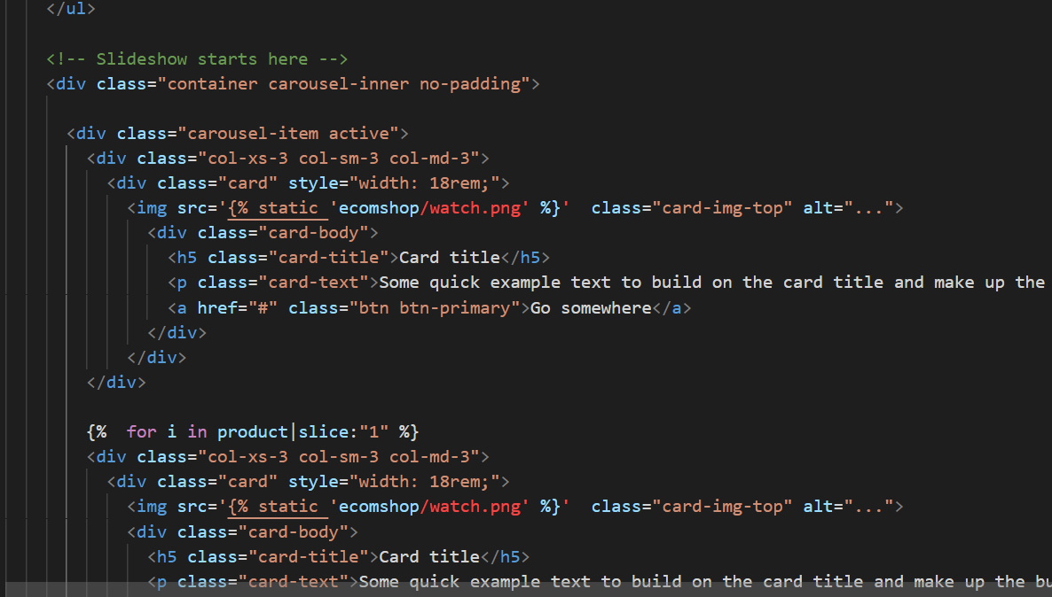

1 we have mentioned above 0th index I’ll handel in first container tag

Slice is similar like list slicing like a[1:-1] first to last

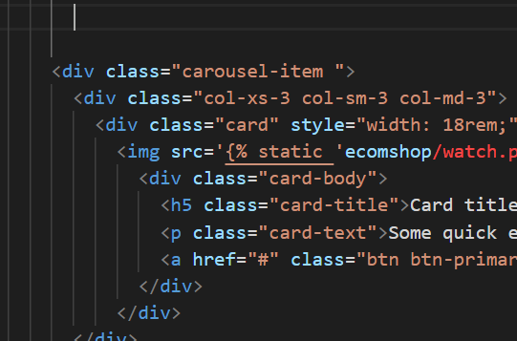

**Now I’ll use crousel items**

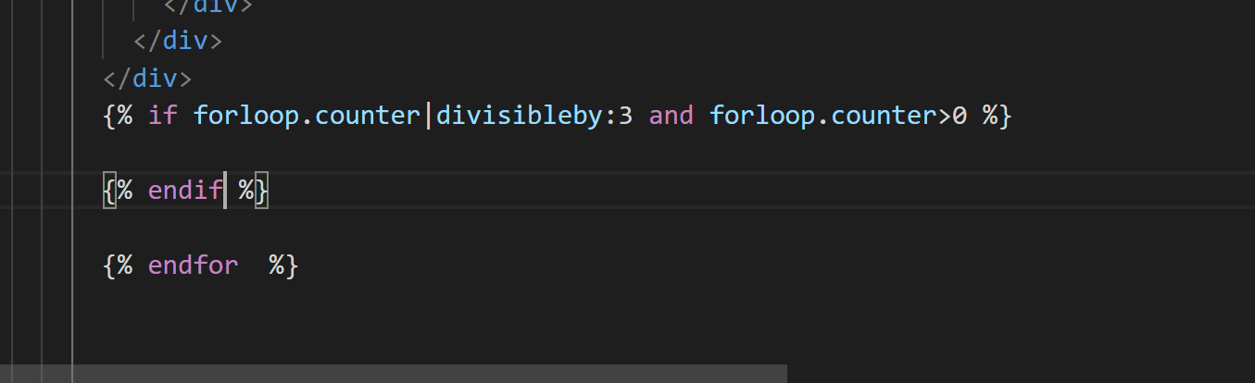

**In item index will start from 0,1, 2, 3 so mentione divisibleby 3 where divisibleby is Django function.**

**Means if length of items divisible by 3 then it should go to next slide**

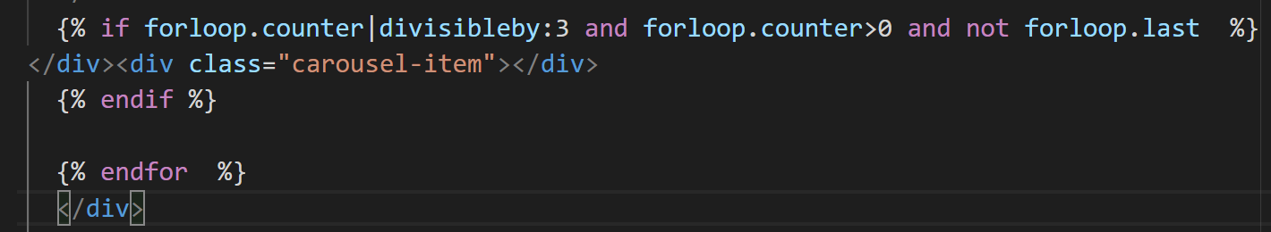

We don’t want above class carousel so ‘not forloop.last’

Delete all other carousel div tag after endfor

Some mistakes I have done items are not moving.

I have made mistake while using div tag their undentation should be correct or else your product won’t be doing carousel scroll properly.

forloop.counter > 0 ;;;;;;if you don’t give space between > you’ll get error.

My mistake:

  {%  for i in product|slice:"1" %}

Mistake due to above only 2 items were displaying.

a[1:] means from 1 to all.

So

{%  for i in product|slice:"1:" %}

Only 5 products I have added in admin page.

Fetching images and data from database

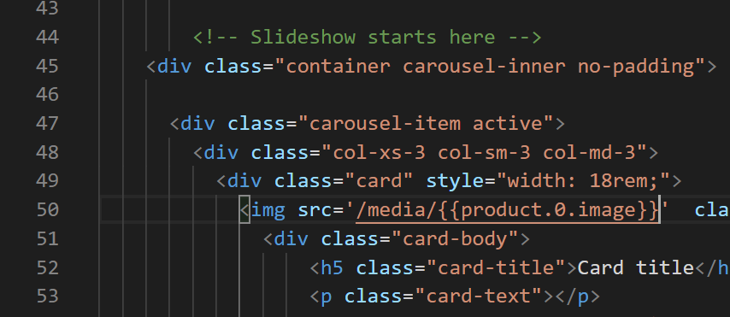

For first item

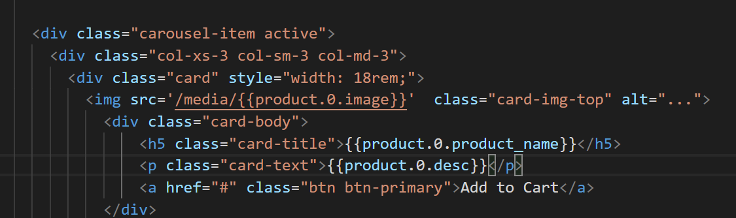

For i elemenets 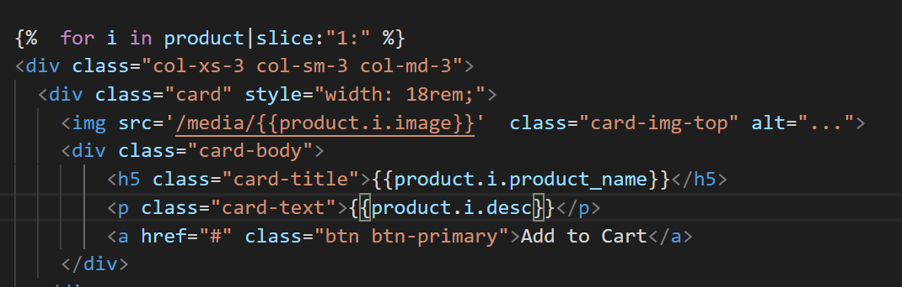

Press right-click -> inspect ->

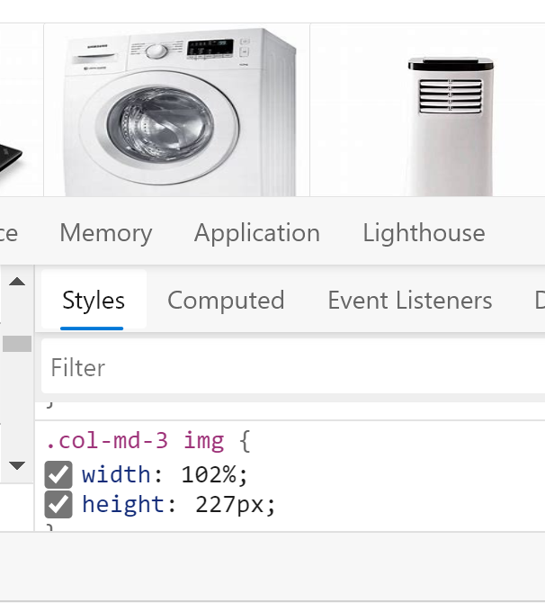Adjust width and height copy those height and width and paste it in css col-md-3 in index.html

Now web page will look fine:

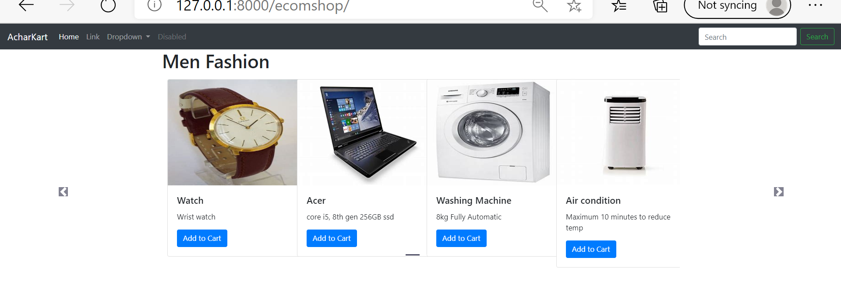

Whatever slides we are showing it is list of lists

Container div tag with carousel-slide-my-3 is main list inside that we are sliding sub lists.

Main aim is to show above imgae like two.

Two scrolling carousel we are gonna do by using lists inside a list.

I need to finish this project so I’m gonna type these things later and explantions are there in codewithharry website notes you can refer that.

Important code snippets I’ll mention here like forloop.counter

Passing below list as parameter:

allProds = [[products,range(1,len(products)),nslides],

                [products,range(1,len(products)),nslides]]

    params = {'allProds':allProds}

    return render(request,'ecomshop/index.html',params)

considering slide starts from here

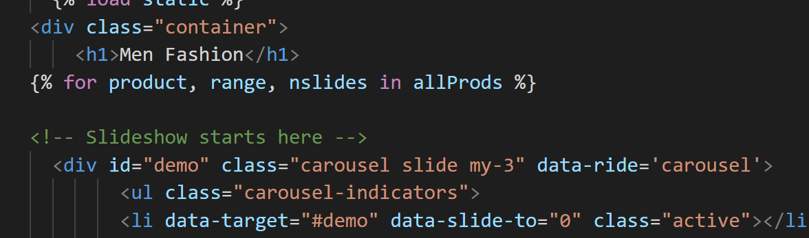

Ending for loop

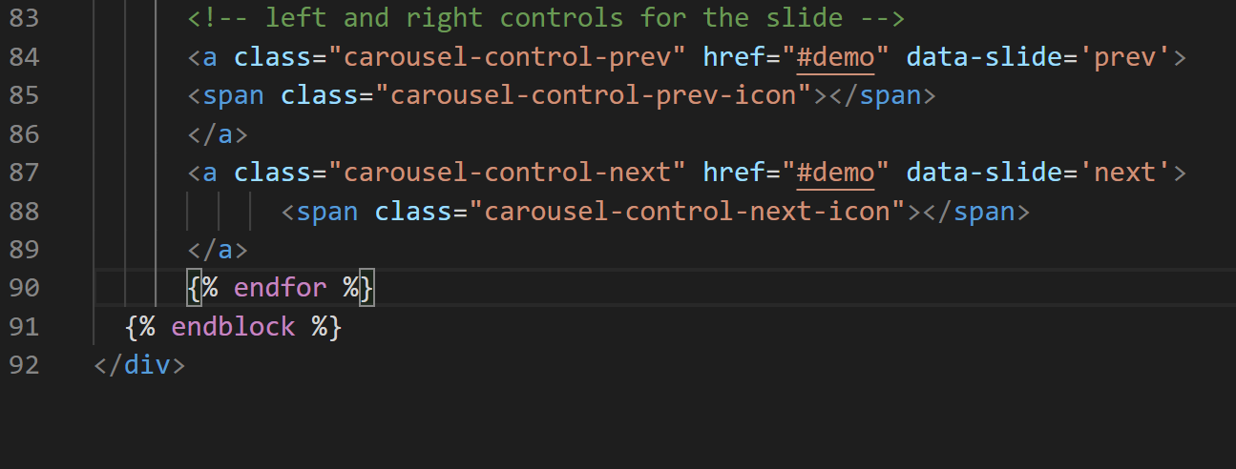

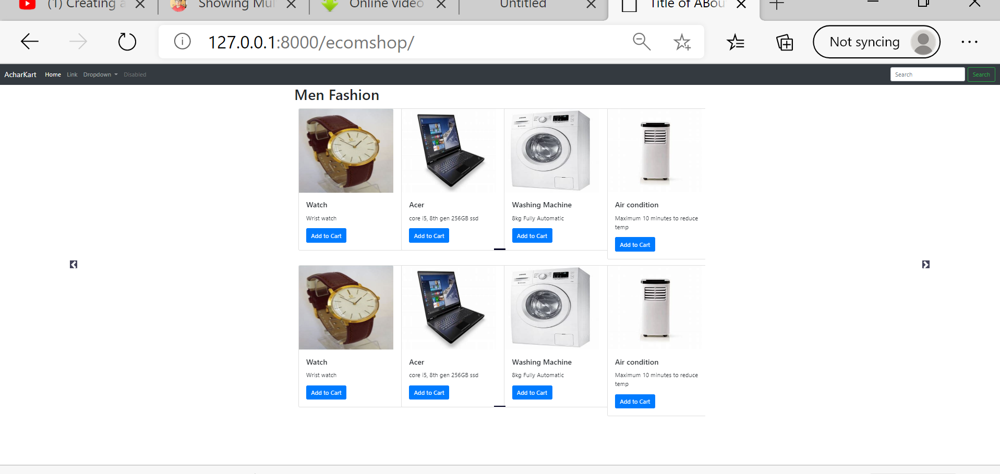

But in above image we are not seeing total 4 buttons to move left2 move right 2.

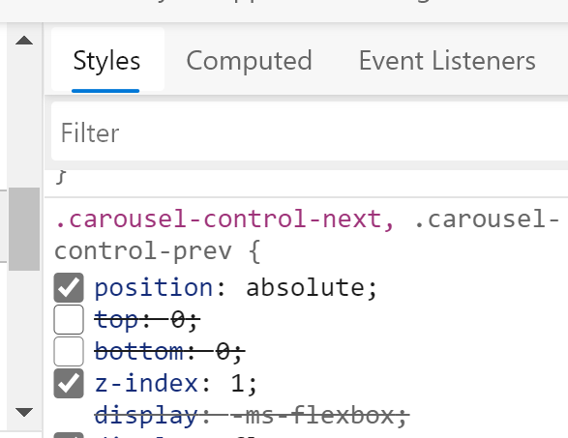

Unseleect top and bottom

Now you can two sliders in single page but 2nd one won’t move

It is because of <a>’s id demo

We have 2 for loops we need to take counter from parent loop not next one

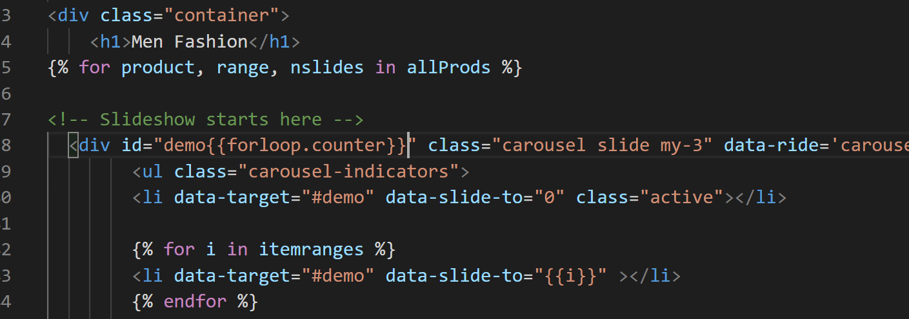

For that use 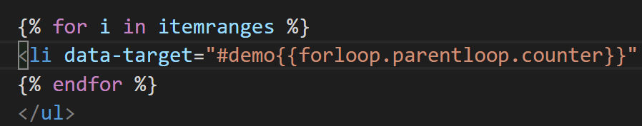

Still buttons are not working

Change demo’s css properties

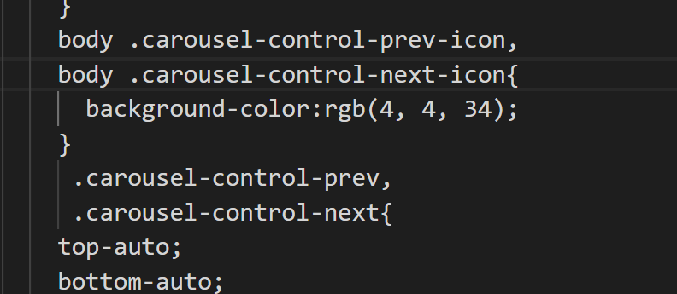

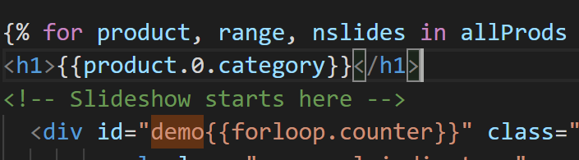

To show category

Showing different categories:

Showing product item directly from classname Products by using key value pair of dictionary

Now after doing this

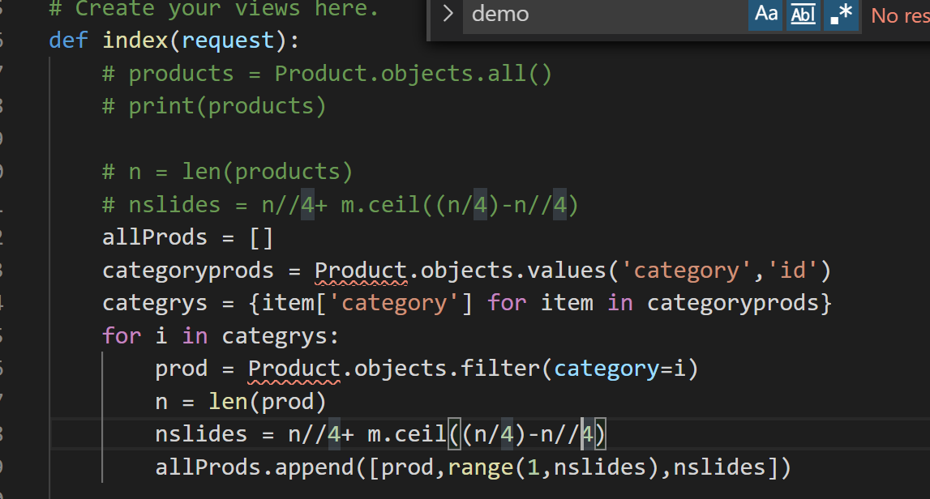

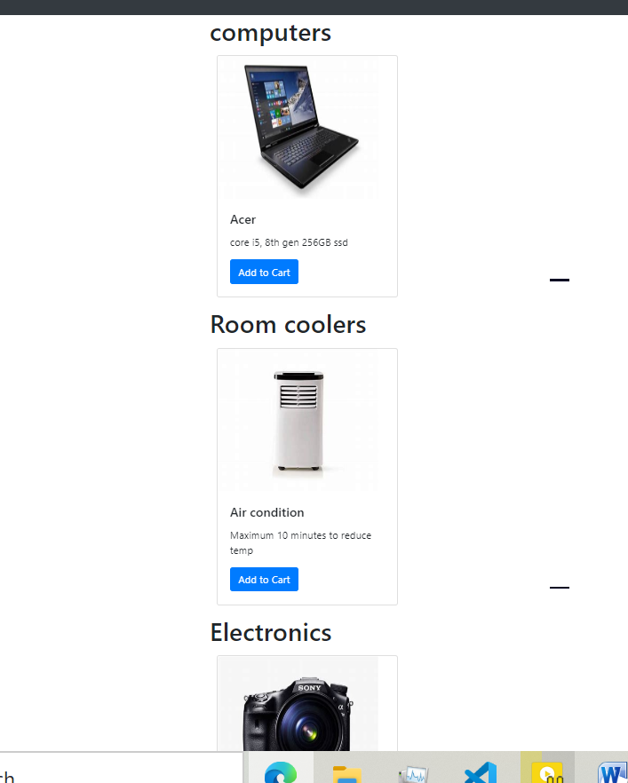

Check with adding similar category items whether it scrolls or not.

Giving margin:

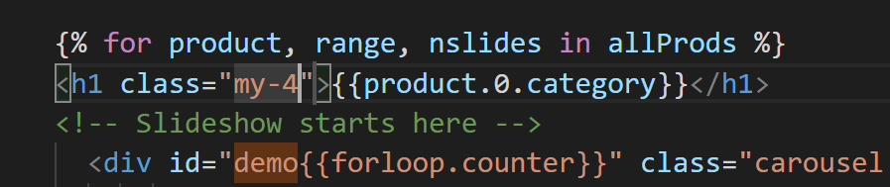

USING JAVASCRIPT:

Using sessionStorage.setItem(‘yadu’,’good’)

sessionStorage.getItem(‘yadu’) will return good in same web page

To set but using this if you go to other web page-> inspect-> console press sessionStorage.getItem(‘yadu’) returns null

So using localStorage.setItem(‘yadu’,’good’)

At any web page if you try to get item localStorage.getItem(‘yadu’) it will return good.

Using stringify function also

Putting javascript:

Basic.html-> after ending of bootstrap put block js and end block

In index.html at the end putting  {% block js  %}  {% endblock  %}

Whatever I type inside index.html block js it will fit with basic.html

Ex:

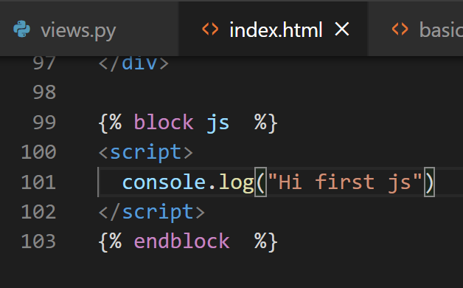

In web page:

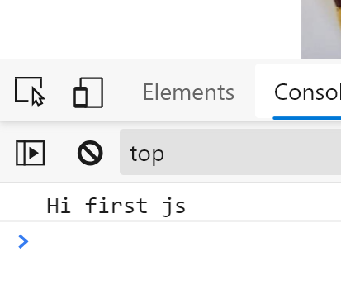

If any item exist in localstroage then load to json or else no

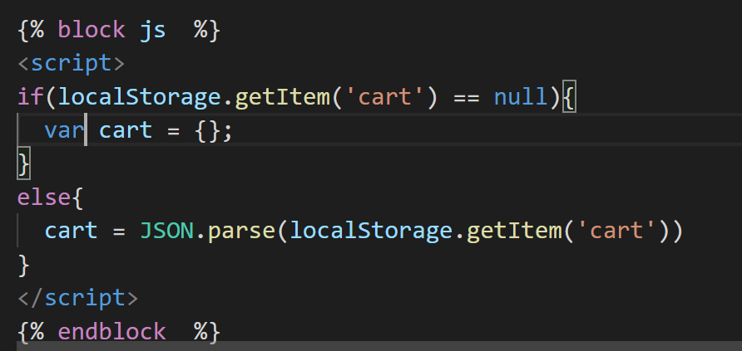

Selecting cart items, if items in cart is there then callback function

$('.cart')

For all buttons give cart class name especially Add to cart

Make your old Add tocart with a tag to button:

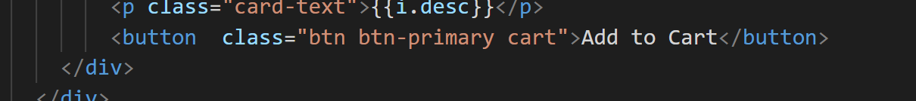

No when you click on add to cart click will increase

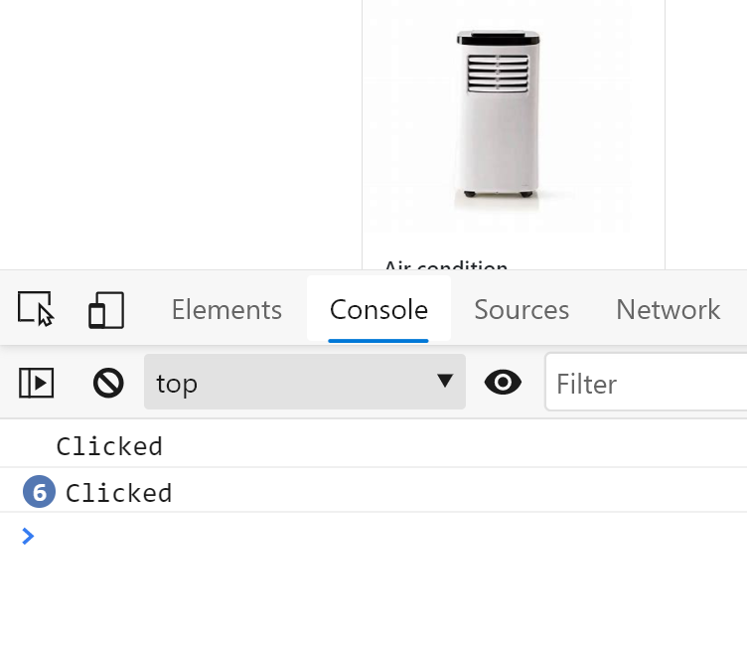

Givinf ids

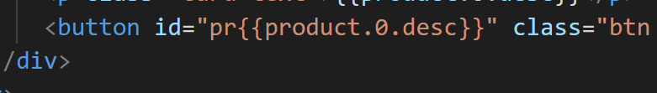

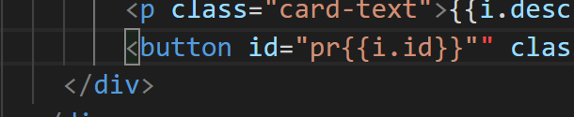

Now returning id using javascript when user clicks on Add cart

}

$('.cart').click(function(){

  console.log('Clicked')

  var idstr = this.id.toString();

  console.log(idstr)

});

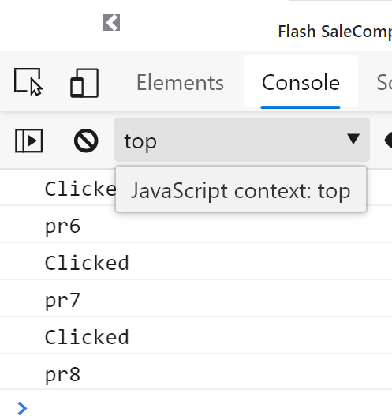

Now finally we can print added items to cart:

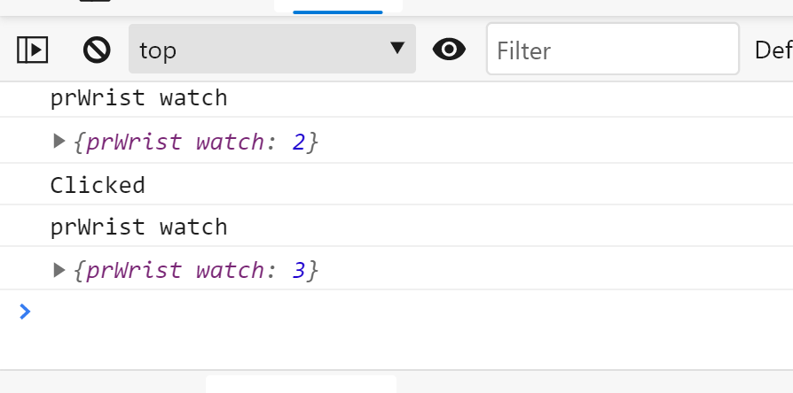

if (cart[idstr] != undefined){

    cart[idstr]+=1;

  }else{

    cart[idstr] = 1;

  }

  console.log(cart);

});

</script>

If key that is idstr is not undefined then increment key of cart or else keep it 1

 console.log(cart);

  localStorage.getItem('cart',JSON.stringify(cart))

because of this previuous item added will be added now

I made a mistake above it should be

console.log(cart);

localStorage.setItem('cart',JSON.stringify(cart))});

^

Testing in other tab:

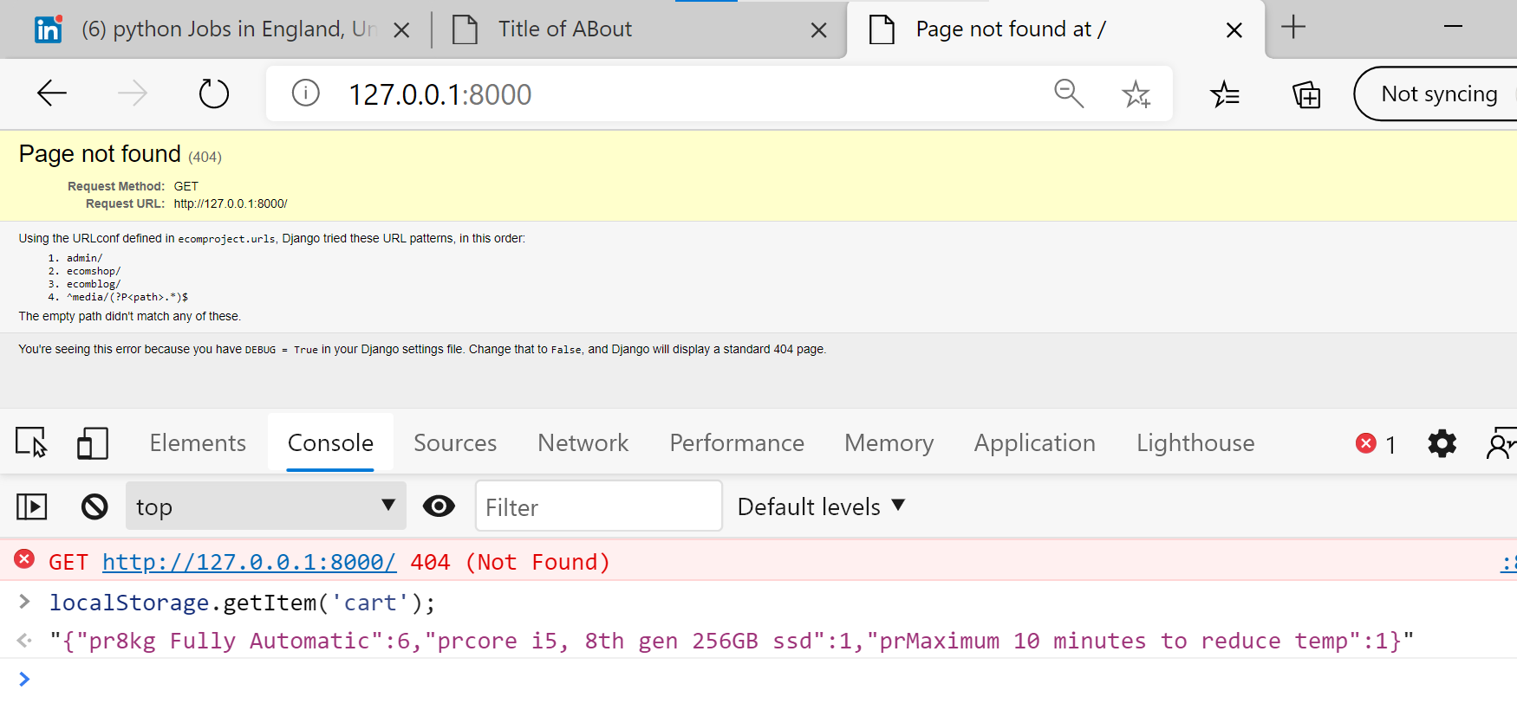

After adding

Improving slider logic:

Delete little bit carousel, selected items only

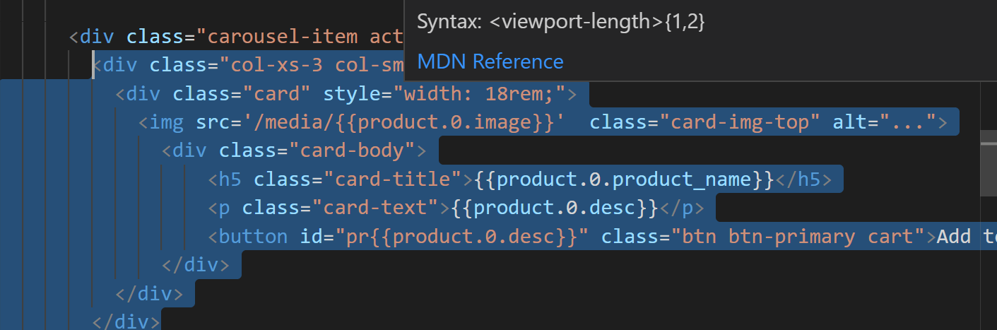

Removing slide: {%  for i in product %}

Add cart in webpage

In basic.html

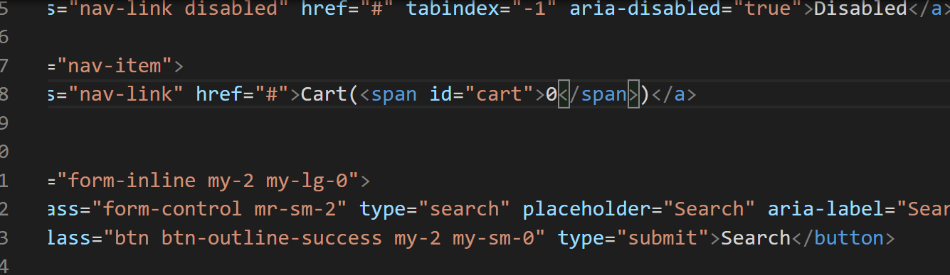

After in index.html

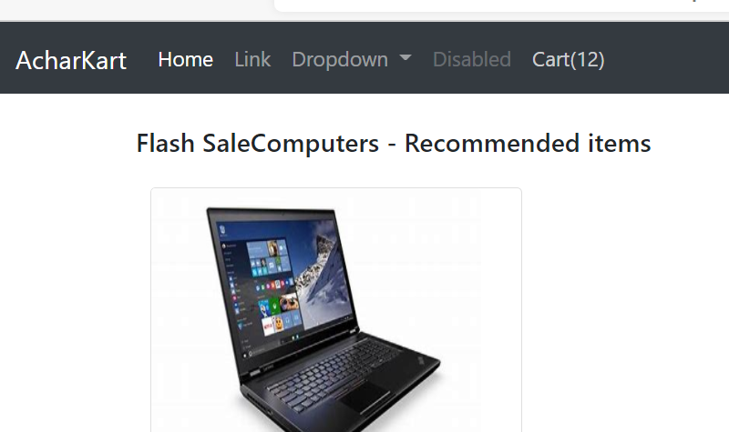

Adding bootstrapwith some css

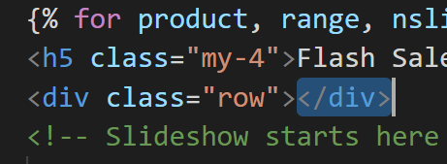

Ending it in for loop

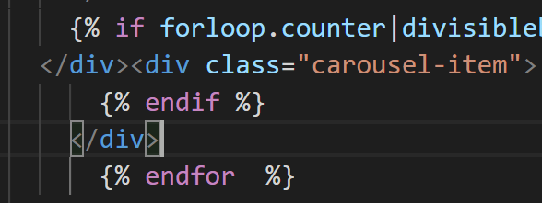

Check ending for loop of that

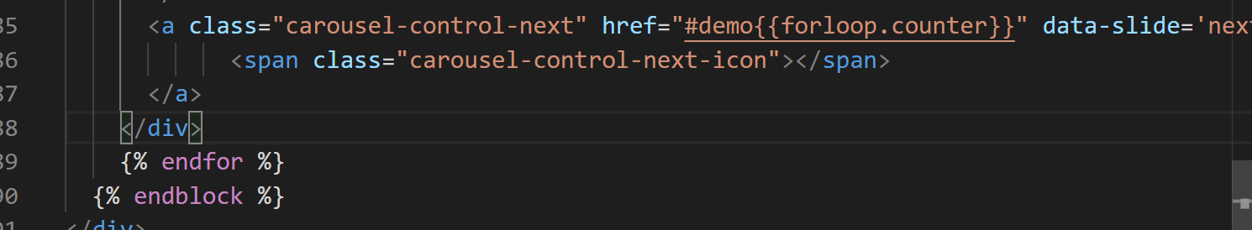

Left right scrolling buttons making it at middle of the image, inspect in web page on that “>”

Removing dropdown from basic.html below one

<li class="nav-item dropdown">

            <a class="nav-link dropdown-toggle" href="#" id="navbarDropdown" role="button" data-toggle="dropdown" aria-haspopup="true" aria-expanded="false">

              Dropdown

            </a>

            <div class="dropdown-menu" aria-labelledby="navbarDropdown">

              <a class="dropdown-item" href="#">Action</a>

              <a class="dropdown-item" href="#">Another action</a>

              <div class="dropdown-divider"></div>

              <a class="dropdown-item" href="#">Something else here</a>

            </div>

          </li>

Putting cart at then end top left

Go to bootstrap->components->tooltips

bottom

<button type="button" class="btn btn-secondary" data-toggle="tooltip" data-placement="bottom" title="Tooltip on bottom">

Tooltip on bottom

</button>

Paste it in after form

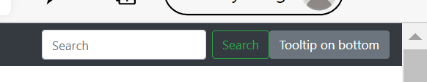

To give margin use mx-2

Inside that pasting cart items

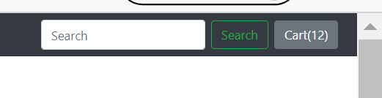



Activating tooltip

Instead tooltip use popover

<button type="button" class="btn btn-secondary" data-container="body" data-toggle="popover" data-placement="bottom" data-content="Vivamus

sagittis lacus vel augue laoreet rutrum faucibus.">

Popover on bottom

</button>

Popover activating in index.html

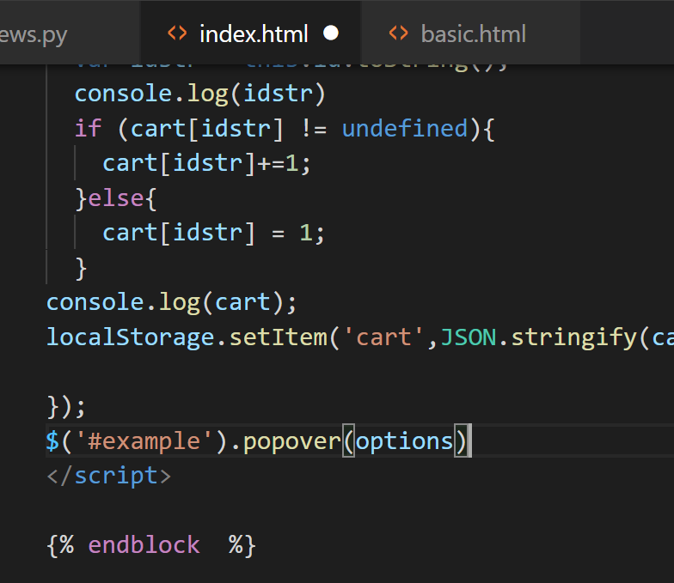



Popover(‘show’)

Example:

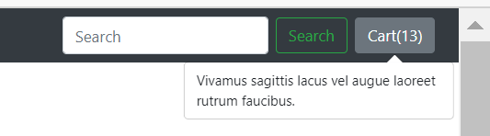



Setattribute is javascript method

Quickview button connecting it from products to productview through

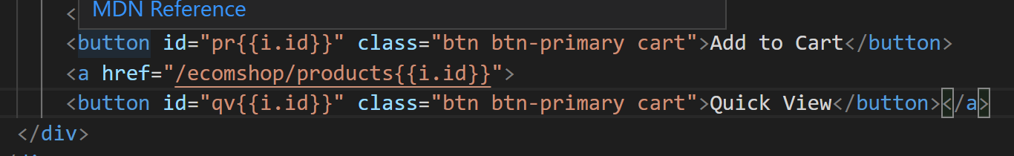

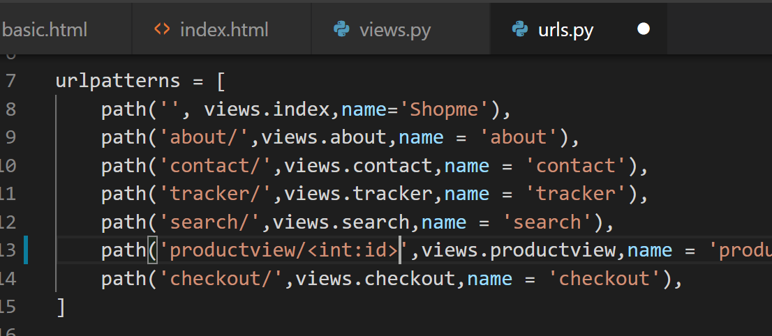Under urls.py adding int: id to productview.

Id will go to views.py

Mistakes solved in index.html:

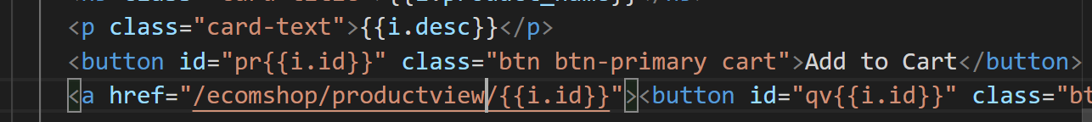

Views.py:

def productview(request,myid):

    # Fetch the product using the id.

    product = Product.objects.filter(id=myid)

    print(product)

    return render(request,'ecomshop/productview.html')

urls.py:

 path("productview/<int:myid>",views.productview,name = 'productview'),

    path('checkout/',views.checkout,name = 'checkout'),

product with same id will be printed in console also:

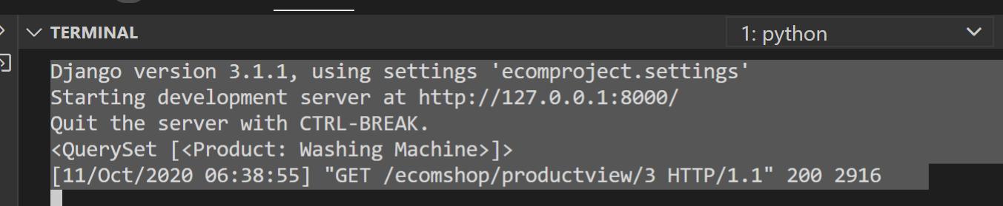

Go to bootstrap: examples to see differnet styles

To make items move like different id’s item displaying copy script inside block js in index.html

Paste it after endblock in productview

Total cart items displayed here also:

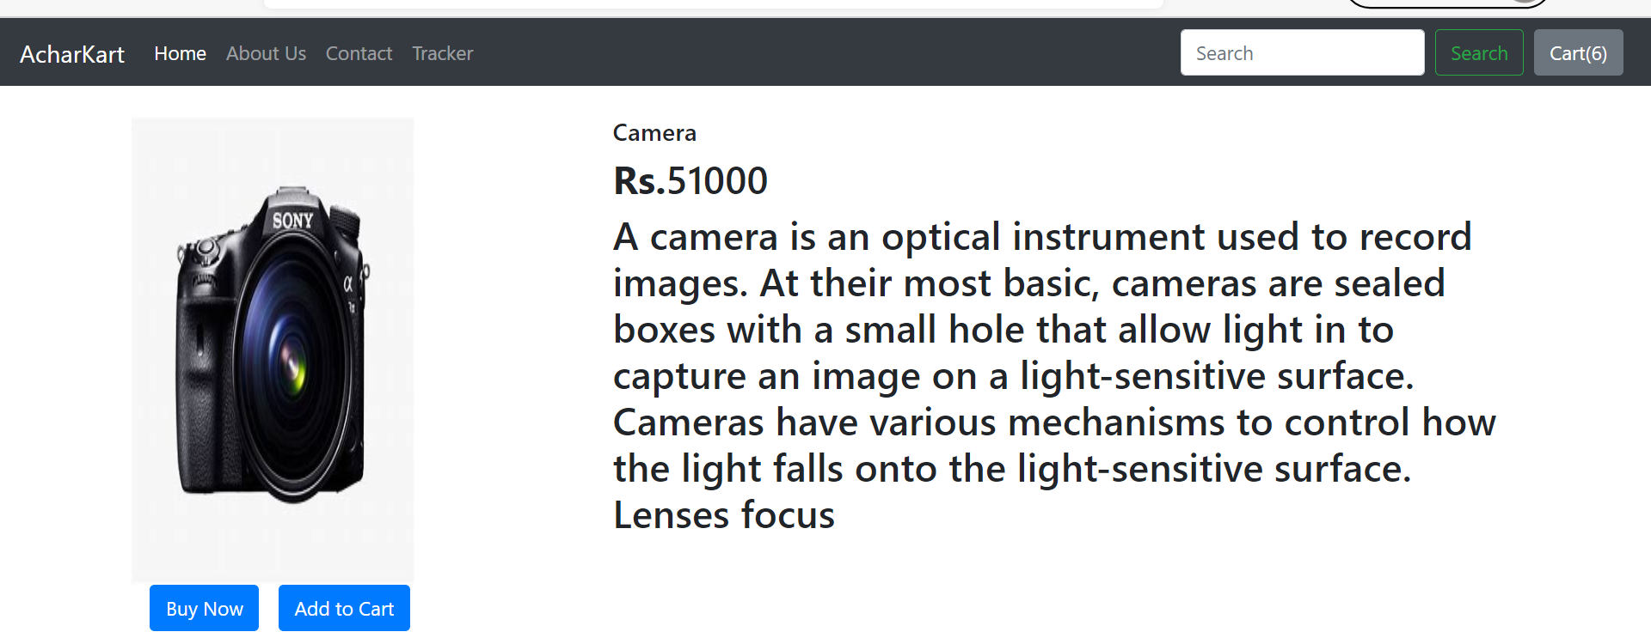

Go to get bootstrap:

Open this 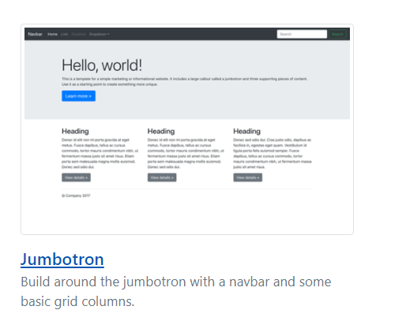

And inspect following stylie similar to that.

Paste it in about .html

Using bootstrap for form text area buttons almost everything is there

Sometime server lags I think so get requet of contact page was not displaying so

I printed

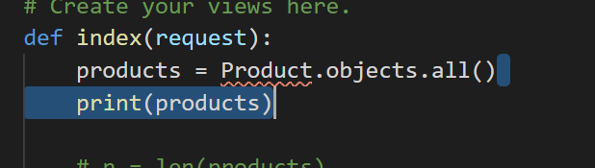

After that when I tried filling contact form it ctarted coming in 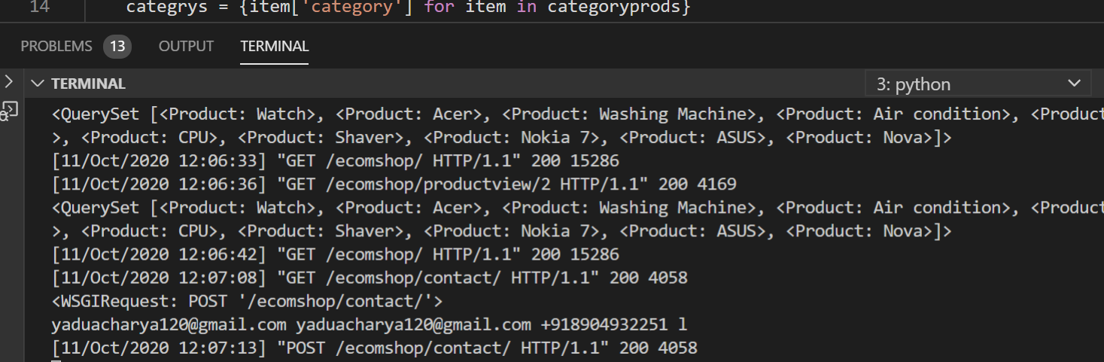

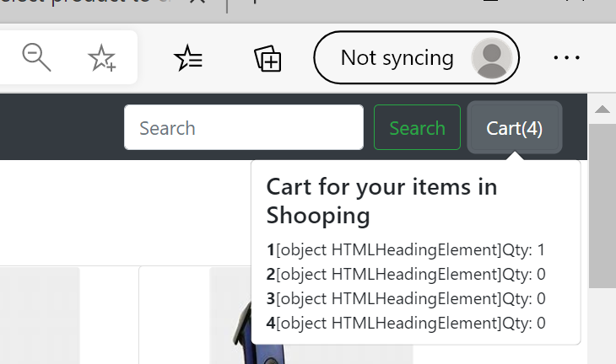

Making these things using javascript function

